EXERCISE 7 - Area of the Mandelbrot Set
Files : area_serial.c, area_parallel.c
Compile / run
gcc -O2 -fopenmp area_serial.c -o area_serial && ./area_serial
gcc -O2 -fopenmp area_parallel.c -o area_parallel
OMP_NUM_THREADS=4 ./area_parallel # mode 0 (default): block mapping
OMP_NUM_THREADS=4 ./area_parallel 1 # mode 1: cyclic mapping
OMP_NUM_THREADS=4 ./area_parallel 2 # mode 2: schedule(dynamic,10)

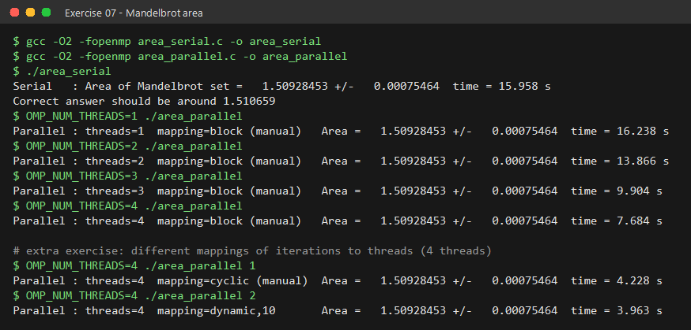
Parallelisation
---------------
#pragma omp parallel default(none) shared(mode) reduction(+:numoutside)
{
int nthreads = omp_get_num_threads(); // library routines
int tid = omp_get_thread_num();
int lo = ( tid * NPOINTS) / nthreads; // equal block of rows
int hi = ((tid+1) * NPOINTS) / nthreads; // for each thread
for (int i = lo; i < hi; i++)
numoutside += do_row(i); // z = z*z + c loop
}

* The parallel region is started BEFORE the main loop.
* z, c, iter, ztemp, j are declared inside the region -> PRIVATE.
* numoutside is a REDUCTION - each thread counts its own escapes and
OpenMP sums them at the end.
* The outer loop is distributed by hand with omp_get_num_threads() /
omp_get_thread_num() so every thread gets the same number of rows.

Results
-------
threads mapping area time (s) speed-up
------- ---------- ---------- -------- --------
serial - 1.50928453 15.96 1.0
1 block 1.50928453 16.24 1.0
2 block 1.50928453 13.87 1.2
3 block 1.50928453 9.90 1.6
4 block 1.50928453 7.68 2.1
4 cyclic 1.50928453 4.23 3.8
4 dynamic,10 1.50928453 3.96 4.0

* The area is IDENTICAL for every thread count (1.50928453 +/- 0.00075).
* Extra exercise: block mapping scales poorly because the work per row is
very uneven - points inside the set run all 2000 iterations, points far
outside escape immediately, so the threads holding the middle rows do
most of the work. Cyclic or dynamic mapping spreads heavy and light
rows across all threads and gives near-perfect speed-up on 4 threads.

